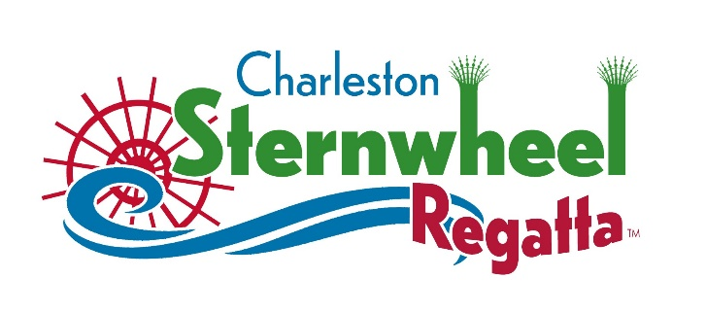
No._______
HOT DIGGITY DOGS PRESENTS
THE CHARLESTON STERNWHEEL REGATTA CAR SHOW
July 2, 10:00a.m. – 6:00 p.m.
REGISTRATION FORM
OWNER/PARTICIPANT:________________________________________________
ADDRESS:___________________________________________________________
CITY:___________________________State:______________Zip Code:__________
EMAIL:_____________________________________________________________

YEAR:______________MAKE:_____________________MODEL:_______________
COLOR:_____________________ MODIFIED: yes________ no________

CLUB AFFILIATION: Yes ______ NO______ NAME OF CLUB:_________________
HOW DID YOU HEAR ABOUT THIS SHOW?_________________________________
HOW MANY MILES WILL YOU BE DRIVING TO THE SHOW?___________________

Registration fee $25.00
Apply in person at Hot Diggity Dog: 2313 7th Avenue Charleston WV 25387 or email Heidi at heidi@charlestonregatta.com Open to the first 125 cars that register.

Sponsored by Charleston Auto and Lorrison Pools

